Lab no. 11:

The marks obtained by 2 groups of student is given below:

|  |  |  |  |  |  |  |  |  |  |
| --- | --- | --- | --- | --- | --- | --- | --- | --- | --- |
| Group a | 44 | 46 | 60 | 50 | 66 | 52 | 35 | 62 |  |
| Group b | 50 | 53 | 40 | 51 | 62 | 63 | 54 | 48 |  |

At 5% level of significance test whether there is significant difference between marks of two groups of student use median test

Hypothesis:

H0: md1=md2 i.e. there is no significant difference between marks of two group of students.

H1: md1≠md2 i.e. there is significant difference between marks of two group of students.

Alpha = 5%

Test statistics:

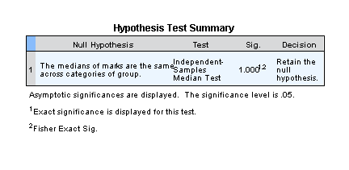

Decision

Hence we accept h0.

i.e. There is no significant difference between marks of two group of students.

lab no. 12

1. The following data represents output of two different treatments.

|  |  |
| --- | --- |
| Treatment 1 | Treatment 2 |
| 46 | 56 |
| 65 | 40 |
| 48 | 52 |
| 55 | 61 |
| 70 | 72 |
| 47 | 64 |

At alpha =5%, test whether output of two different treatment are similar. Use median test.

Hypothesis:

H0: Md1=Md2 i.e. the output of two treatments are similar.

H1: Md1≠Md2 i.e. the output of two treatments aren’t similar.

Alpha = 5%

Test statistics:

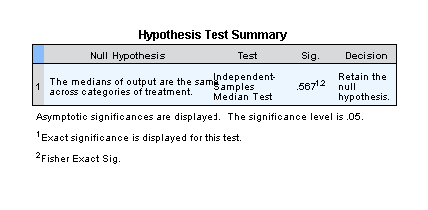

Decision

Here we accept h0,

We conclude that the output of two treatments are similar.

Lab no 13:

1. The following table represents the operating time of 3 different brands of scientific calculator.

|  |  |  |
| --- | --- | --- |
| A | B | C |
| 4.8 | 3.8 | 3.9 |
| 5.9 | 4.0 | 5.0 |
| 6.4 | 5.9 | 6.2 |
| 5.0 | 6.1 | 5.2 |
| 4.4 | 4.7 | 5.7 |
|  | 7.0 |  |

At 5% level of significance test whether there is significance difference between operating time of 3 different brands of calculator using kruskal wallis H test.

Hypothesis:

H0: There is no significance difference between operating time of 3 brands.

H1: There is significance difference between operating time of 3 brands.

Alpha = 5%

Test statistics:

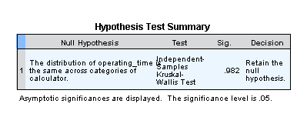

Hence we conclude that There is no significance difference between operating time of 3 brands.

Lab no 14:

1. In an experiment to determine which of 3 different missile system is preferable, the propellent burning rate is measured. The data after coding are given in the table. Use Kruskal wallis test significace level of 0.01 to test the hypothesis that the propellent burning rates are same for the three missiles system.

|  |  |  |
| --- | --- | --- |
| Missile system A | Missile system B | Missile system c |
| 22.3 | 23.4 | 18.4 |
| 16.7 | 19.5 | 19.5 |
| 22.7 | 17.5 | 17.8 |
| 19.3 | 20.8 | 18.0 |
| 18.5 | 16.0 | 19.6 |
|  | 19.9 | 22.8 |
|  |  | 17.1 |

Hypothesis:

H0: the propellent burning rates are same for the three missiles system.

H1: the propellent burning rates aren’t same for the three missiles system.

Alpha =5%

Test statistics:

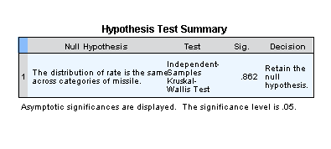

Conclusion:

Here we accept h0 i.e. the propellent burning rates are same for the three missiles system.